NDIS home modifications

Guidance for builders and designers
Version 2.0 – September 2022
ndis.gov.au

Contents
NDIS home modifications 1
Guidance for builders and designers 1
Contents 2
1. Introduction 3
2. NDIS home modifications 4
3. Complex home modifications 7
4. Key areas of focus 9
5. Dwelling access/entrance 10
6. Internal dwelling access 13
7. Bathroom 15
8. Bedroom and living areas 20
9. Ceiling hoists 22
10. Kitchen and laundry 23
11. Home automation 24
12. New building modifications 25
13. Maintenance and upgrades 27
Appendix 1 29
Appendix 2 30
Appendix 3 31

Introduction
The National Disability Insurance Scheme (NDIS) plays a vital role to improve outcomes for NDIS participants. We aim to empower and support participants to access activities and take part in social, work and community life.
Home modifications help participants be safer and more independent in their homes. These changes to homes can have a big impact on how participants live their lives. They allow greater flexibility and support participants to choose how they want to live. We explain how we assist participants who need home modifications in Our Guideline – Home Modifications.
This guidance aims to provide examples for builders, designers (including home modification assessors) and any other stakeholders involved in the planning, decision making and delivery of home modifications for NDIS participants. This supplements the official policy in Our Guidelines.
We fund a diverse range of home modifications to help participants pursue the goals in their NDIS plan. Home modifications are classified as minor or complex based on their cost, risk level, complexity, and the extent of their construction (whether they are structural or non-structural).
This guidance aims to help builders and designers (including home modification assessors) understand:
- The NDIS funding criteria for home modifications in a participant’s plan.
- The typical scope of works for complex home modifications.
- The scope of works that may exceed the NDIS funding criteria.

NDIS home modifications
Home modifications are custom-built changes to the structure, layout or fittings of a home to help the participant safely access, move around in, and use their home.
The supports we fund in a participant’s plan need to meet each of the reasonable and necessary criteria outlined in the NDIS Act 2013, section 34(1)(a)-(f), and the NDIS (Supports for Participants) Rules 2013.
An extract of the relevant rules is in Appendix 2.

There are two broad categories of NDIS home modifications

Minor home modifications
Minor home modifications are custom-built changes in the home, that generally:
- are straightforward, non-structural changes
- have a relatively low risk of major problems arising
- only affect one or two areas of the home
- cost less than $20,000 in total.
An assessment is required for minor home modifications from an occupational therapist (for Category A works $10,000 or under) or a home modifications assessor (for Category B works between $10,000 and $20,000, or involving modifications to a bathroom floor). A home modification assessor is an occupational therapist with qualifications and experience to recommend more detailed or complex home modifications.
In general, requests for minor home modifications do not require quotes to be submitted to the NDIA; we will use a set NDIS budget for each type of modification.
Generally minor home modifications do not require additional support for planning or independent oversight by an independent building practitioner, because of the lower risk involved.
Note: cost thresholds are generally based on building in Modified Monash Model (MM¹) 1 areas. The NDIA may accept modifications above the threshold as Minor HM where building costs are higher in remoter areas.

¹ See https://www.health.gov.au/resources/publications/modified-monash-model-fact-sheet

Complex home modifications
Complex home modifications are usually structural, custom-built changes that generally:
- are higher cost
- are higher risk
- involve several areas of the home
- require a greater level of building permissions and certifications
- have a greater impact on participants’ lives while they are being constructed.
An assessment is required from a home modification assessor for complex home modifications. Find out more in Our Guideline – Home Modifications.

General principles and requirements
A participant may choose to contribute their own funding for any home modifications or features that don’t meet the NDIS funding criteria. This might include:
- higher standard (more expensive) finishes
- any extra costs associated with a different home modification solution or features
- extending the scope of works beyond what meets the NDIS funding criteria.
Participants have this flexibility as long as any changes still achieve an equal outcome to the supports we have approved. The service agreement or contract between the participant and the builder needs to clearly identify the private works separately from the NDIS funded works.
The following assumptions also apply:
- Builders doing NDIS home modifications must understand and comply with the relevant National Construction Code, standards and regulations within the State or Territory where the work is being done.
- Where a local authority has requirements, the builder’s quote must meet this certification of works.
- The builders quote should note and justify any variations from the National Construction Code practice.
- Builders will provide insurance to at least the value of the modifications.

Quotes
Builders’ quotes for NDIS funded home modifications works (whether required to be submitted to the NDIA or primarily to assist the participant) must be itemised and detailed enough to enable accurate comparisons based on the same scope of work, or for audits. All required information must be provided if submitting a quote for a NDIS home modification.
Appendix 1 outlines the minimum information needed for quotes.

Australian Standards
This guidance references:
- Australian Standard 1428 Design for Access and Mobility Part 1 (General) (AS 1428.1)
- Australian Standard 1428.2 (1992-RA) 2019, Part 1 – Ambulant individuals and Part 2 – Individuals with complex disabilities.
- Australian Standard 1428.1 is not specifically intended for residential dwellings and compliance is not mandatory, however it does provide an outline for good practice in home design for people with disabilities. Note that local council or municipal statutory requirements are applicable, and these may default to Australian Standard 1428.1.
- Builders are expected to adhere to the design requirements for new building work, as required by the National Construction Code, to enable access for people with disabilities unless otherwise required to follow Australian Standard 1428.1.

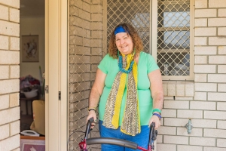

Minor home modifications
We have calculated a reasonable budget for each type of minor home modification and published these on the NDIS website. Developed by an independent professional quantity surveyor, they are based on recent industry data and include allowance for regional and rural loadings. For remote and very remote locations (MM 6 and 7) a quote from a suitable provider is still required for us to set a suitable budget.
Once a participant’s plan is approved with minor home modification funding, they can engage a suitable builder to get quotes for funded works and any personal requirements. We expect the participant (or their nominee/project manager) to complete the modifications within the available budget.

Minor home modification process outline
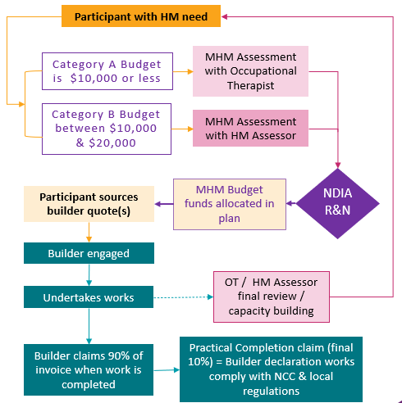

Staged payments may be part of a building contract, however, we will include 10% of the total budget against a final Practical Completion claim.
The builder must provide all necessary certifications and permits to the homeowner, and the participant provides acceptance of completed works, prior to a Practical Completion claim.

Complex home modifications
We will fund a building construction practitioner to help the participant and home modification assessor with planning the scope of works for a complex home modification. The building construction practitioner also may help the participant undertake due diligence for builders and get quotes for the job. This person must be independent of the builders who will quote for the works. The building construction practitioner can also take on the building works project manager role for the participant.
Builders’ quotes for NDIS funded home modifications works must be itemised and detailed enough to enable accurate comparisons based on the same scope of work, or for audit purposes. The minimum quote information we need is in Appendix 1.
If the works are highly complex, we may also fund an independent building works project manager to help the participant:
- review the building contract
- coordinate with stakeholders
- check progress and quality of the building works at key milestones
- help the participant resolve issues as they arise.

Complex home modification process outline

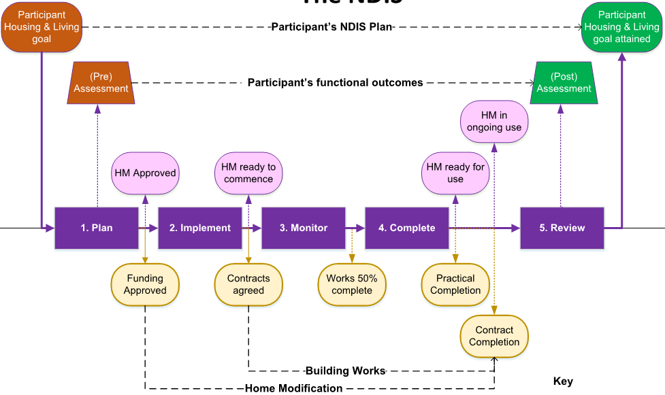

Key areas of focus

These guidelines include the following key areas for home modifications:

Dwelling access/entrance

Dwelling internal access

Bathroom

Bedroom and living areas

Ceiling hoists

Kitchen and laundry

Home automation

Building a new home

Making good / finishing the home modification including painting, repairs and cleaning up

Maintenance and upgrades

Dwelling access/entrance
To enable participants’ safe and continuous access to their home.

Typical scope of works

External path of travel
If it’s supported by clinical evidence, we can fund an external continuous accessible path of travel to enable the participant to safely enter and exit their home. The NDIS funding criteria allow for a pedestrian path of travel from the front boundary or the car parking area, to one accessible entrance of the dwelling.

A new path of travel is recommended to be:
- made from reinforced concrete (not pattern paving, exposed aggregate, polished, stencilled or coloured concrete), or other suitable cost-effective products
- a minimum width of 1000mm, or wider if clinical evidence shows the participant needs a wider wheelchair or mobility aid
- a slip resistant surface, such as concrete broom finish or wooden trowel finish.

For an existing path of travel:
- any steps, obstructions, or hazards along the path of travel should be removed
- in some cases, the existing path may be widened if it meets the NDIS funding criteria.

External path of travel for an additional external door (fire safety)
If the participant needs an additional external entrance door from the home for a fire exit, which meets the NDIS funding criteria, then the scope of works may also need to include a connecting section to an external path of travel for the additional doorway.

Dwelling entrance – ramps
Access ramps are commonly used to replace steps or stairs for people with wheelchairs or other mobility assistive technology.

Ramps should be made from:
- timber frame (preferably structural treated pine) with a trafficable surface of timber decking type material (preferably reeded treated pine),
- reinforced concrete (not pattern paving, exposed aggregate, stencilled or coloured concrete) with a slip resistant surface such as concrete broom finish or wooden trowel finish, and/or
- timber and other composites if costs and performance are comparable or better to the above.

Ramps are recommended to have:
- a minimum width of 1000mm between the handrails for a straight configuration, or wider if clinical evidence shows the participant needs a wider wheelchair or mobility aid
- a 1200mm wide level landing at the top and bottom of the ramp – consider the angle of approach and the door position
- a maximum length of 9000mm without an intermediate landing
- 1 in 14 maximum gradient
- a 1 in 8 maximum gradient step ramp (as per NCC 2019 BCA), if an occupational therapist recommends this for a participant
- an intermediate landing of a minimum of 1550mm width where a ramp has a 180-degree change in direction.

Notes
- An assessor (occupational therapist or home modification assessor) must recommend specific design requirements for ramps based on clinical evidence to address the participant’s individual needs.
- For Class 1 dwellings, ramps do not need to strictly comply with Australian Standards 1428.1, but local council or municipal statutory requirements may apply and may default to Australian Standards 1428.1. The builder or designer must check local council/regulatory requirements.
- Please refer to the Australian Standards 1428.1 for minimum landing dimensions based on angle of approach and door operation.

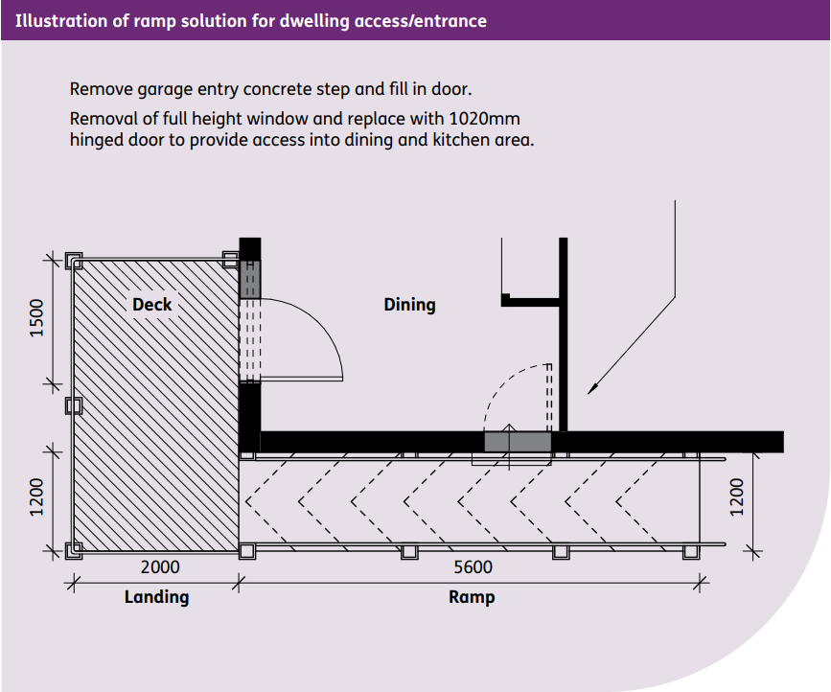

Dwelling entrance – platform lift
If the internal floor level of the participant’s dwelling is more than 1000mm from the external pathway, then ramp or stair access may not be suitable for access to the dwelling.
Where steps are not suitable or can’t be made safe, a vertical platform type lift (compliant with the relevant parts of Australian Standards 1735) may be recommended in the scope of works.
If a platform lift is recommended, the product should be rated as suitable to be installed without a weather cover.

Dwelling entrance – vertical lift (enclosed lifts)
If the participant resides in a multi-level dwelling, a vertical lift may be recommended in the scope of works.
If a vertical enclosed lift will be placed external to the home, the product should be rated as suitable to be installed without a weather cover. All lifts/elevators must comply with the relevant Australian standards and local regulations.
The participant’s internal access needs will also need to be considered.
Platform or vertical lifts must comply with the relevant part of Australian Standards 1735.

Internal dwelling access
To enable participants to access necessary areas in their home that they can’t access because of their disability.

Typical scope of works

Door widening
Where participants rely on mobility assistive technology, such as four-wheel walkers or wheelchairs, the NDIS funding criteria may be met with an assessment to widen doors or entrances providing access through:
- one external entrance door, usually the main front door or door linked to the external continuous accessible path of travel
- one bathroom door, specifically to the bathroom being modified or that contains an accessible toilet and shower
- the entrance to at least one living area within the dwelling
- the kitchen door
- the participant’s nominated bedroom
- additional bedroom(s) the participant needs to access.
Planning authorities may require a development application to widen an external door. Builders must check the state/territory building regulations and local council planning requirements for planning modifications.

Flooring
Where participants use mobility or transfer assistive technology, such as a wheelchair or mobile hoist, an assessment to replace the flooring in frequently used rooms may meet the NDIS funding criteria.
We will typically fund the installation of vinyl planking or other suitable flooring in the participant’s nominated bedroom and living area.
We will also consider funding flooring replacement as an ancillary cost to other modifications, for example bathroom modifications. Other disability related living environment needs may also be most cost effectively addressed through a change to flooring.

Works that may not meet the NDIS funding criteria
If an item does not meet all the NDIS funding criteria, the homeowner or participant may choose to include these items in the home modifications and separately fund them with the builder.
These items may include, but are not limited to:
- house extensions to increase circulation space of living areas or to provide additional habitable rooms. If the participant needs additional floor area to access a bathroom and/or bedroom, then we may consider funding an extension of floor space
- conversion of garages to provide an additional habitable room
- replacement of floor coverings, other than in situations where the existing floor covering severely limits mobility, or where sections of flooring need replacing due to other modifications needed.

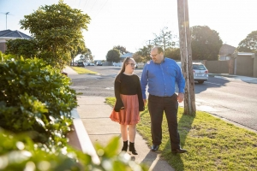

Bathroom
To provide participants with safe and accessible amenities for personal care and hygiene.

Typical scope of works

Location
Modifying an ensuite or shared bathroom in a participant’s home would typically meet the NDIS funding criteria.
If a participant’s dwelling has more than one bathroom, the assessor will consider its location and existing plumbing and fixtures to recommend which bathroom should be modified.
Typically, a modified accessible bathroom will contain a shower, hand basin and toilet in the same room. But in some situations the toilet may stay in a separate room.
Preferably the shower, toilet, and hand basin will remain in their existing locations unless there is clinical or structural evidence to justify moving them. This could be to make it more functional, safe and accessible, or to increase circulation space for the participant.
An open, stepless shower can enable access. Ideally, a stepless shower should not be adjacent to a doorway because of the potential for water to escape, or the need for a barrier which may reduce access. But in many domestic bathrooms it may be impractical to move the shower away from a doorway, due to the limited size and existing configurations of the bathroom.
Refer to Shower Curtains for more information about open showers adjacent to doorways.

Demolition
The builder should clearly nominate all demolition works for bathroom modifications, which would typically include:
- the bathroom door and associated material if it’s being widened
- bathroom fixtures such as plumbing fixtures (bath, shower, toilet, vanity and hand basin) and bathroom fittings (toilet roll holder, towel rails, robe hooks, mirror)
- existing shower hob
- existing flooring, such as vinyl or floor tiles
- internal sections of wall, incorporating an adjacent toilet as part of an enlarged accessible bathroom
- sections of wall lining needed to access plumbing and install wall reinforcement
- sections of sub floor to build a new stepless shower base. This would include a nominated section of timber flooring or structural concrete slab, to enable floor grades for a new stepless shower base.

Fittings and fixtures
Where possible, fittings and fixtures that can be successfully salvaged in a cost-effective way during demolition can be re-used. While it’s best to minimise costs, this is not always practical or achievable. Some fixtures, such as mirrors, may be fixed to surfaces with high strength adhesives which can’t be removed without damaging the fixture.
The builder should clearly list:
- any fittings and fixtures intended to be re-used, or not disturbed
- all proposed new fittings and fixtures, for example:
- grab rails
- towel rails, which may be grab rail specification to prevent falls
- taps, hand-held shower heads
- plumbing fixtures, including for toilets and hand basins
- bathroom storage like cabinets, cupboards and shelving
- shower screen/curtain.

Plumbing
All plumbing work for shower modifications must be specified, such as new floor waste connections, water outlets, and new taps/water mixers.
A Thermostatic Mixing Valve (TMV) is required for new bathrooms, if there isn’t one already. Most hot water systems now deliver water to a pre-set maximum temperature. So while a TMV may meet the NDIS funding criteria based on clinical evidence, an existing hot water service should be checked to see if it has a pre-set maximum temperature.

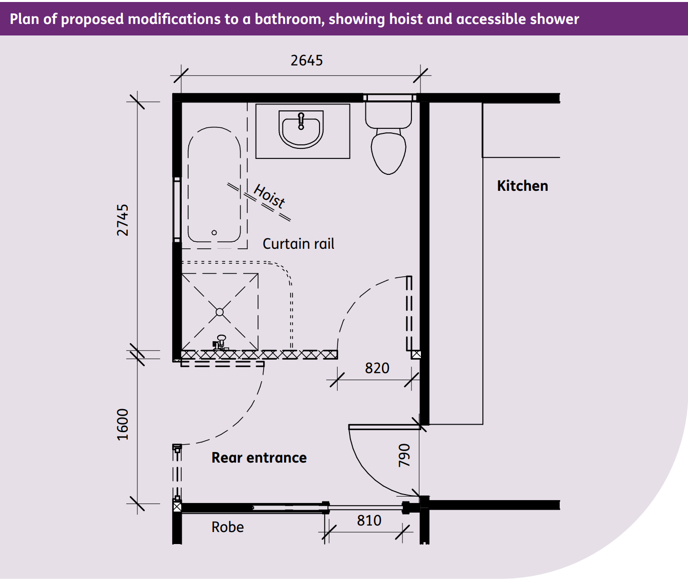

Shower
Size
A 1500mm x 1500mm stepless shower base is ideal where possible. Australian Standards 1428.1 specifies the minimum size for a shower base is 1160mm x 1100mm. For participants with enhanced requirements, Australian Standards 1428.2 should be referenced.
Waterproofing
The specifications in Australian Standards 3740 for waterproofing (to walls and floor) are:
- For an unenclosed shower, the waterproofing should extend a minimum of 1500mm from the wall connection of the shower rose.
- Vertical flashing, which can be external or internal, needs to terminate a minimum of 1800mm above the finished floor level.
- The waterproofing membrane should be applied over the floor substrate and at a minimum height of 150mm up the vertical face of the wall, above the finished floor level.
- Where the extremity of the shower is located within 200mm of an exit from a wet area. It shall have a vertical waterstop (screen) where the shower abuts the wall. It should have a fixed screen of approximately 300mm in width.
The builder must provide a certificate of waterproofing compliance.
Flooring
The section of flooring removed to incorporate a new stepless shower base must be replaced and made good.
Floor grades for a stepless shower must be between 1-in-60 to 1-in-80 to a central floor waste or lineal grate.
Flooring must be a suitable non-slip material like vinyl or floor tiles. The bathroom floor to stepless shower transition should not incorporate any change of level, such as the abutment to tiles.
Shower walls
Any disturbed sections of bathroom walls need to be re-clad with suitable wet area lining or an appropriate substrate surface for wall tiling.
Shower wall tiling, or other waterproof impervious wall finish like vinyl or laminate sheeting, must be provided to an extra tile height to cover tall people and fixtures (the shower-rose outlet wall location up to 2100mm) above the finished floor surface. Shower wall tiling will extend beyond the shower perimeter (100mm beyond the shower base) for 1500mm in both directions (along both walls) horizontally.
Wall reinforcement to enable grab rails to be securely fixed may be needed. Wall reinforcement should be noggings, studs, wall trimmers or at least 12mm structural plywood sheeting.
Plywood wall sheeting would be secured between 600mm and 1850mm above the finished floor surface vertically, and along both walls from the corner of the shower to 900mm in both directions horizontally. This will ensure more flexibility for different types, lengths and locations of grab rails to suit the participant.

Shower curtain
A shower curtain would typically be on a suspended ‘L’ shaped curtain track with intermediate ceiling support.
If an open shower is within 300mm of the bathroom door, then a barrier will be required to comply with the waterproofing standard.
A small, fixed shower screen nib of at least 150mm wide to prevent water splashing under the shower curtain would protect the bathroom entrance from moisture. The shower curtain would slide along the inside of the nib.

Toilet
Where practical, the existing toilet pan and cistern should be retained. Modifications to an existing toilet which may meet the NDIS funding criteria include:
- replacement of the toilet seat
- wall-mounted grab rails, drop-down grab rails or other assistive technology.
A new toilet pan and cistern would need to meet the NDIS funding criteria. An Australian Standard 1428.1 compliant toilet pan may be effective and beneficial based on clinical evidence, align with current good practice, and represent value for money. However, there are typically many toilet suite models that are suitable for participants.
Consideration should be given in the first place to resolving toilet access via a commode or an other assistive technology solution before repositioning or replacing the toilet pan is recommended. The position and set-out of the toilet pan is often what makes a toilet functional, safe, and accessible.

Hand basin
Where practical and appropriate, the existing hand basin/vanity would be retained. Modifications to a hand basin/vanity that may meet the NDIS funding criteria include:
- modifications to existing vanity joinery so a participant who uses a wheelchair has knee and foot clearance
- replacement of an existing hand basin with a new semi-recessed hand basin to make it accessible for a participant who uses a wheelchair. This would also most likely require a new vanity top
- changed height of a hand basin and/or vanity for a participant based on clinical evidence
- accessible taps like mixer taps with lever handles, and possibly extended lever handles.

Works that may not meet the NDIS funding criteria
If an item doesn’t meet the NDIS funding criteria, the homeowner or participant may choose to include these items in the home modifications and separately fund them with the builder.
These items may include, but are not limited to:
- upgrade or replacement of the existing hot water system
- plumbing works beyond the modified bathroom
- replacement of taps, shower heads or plumbing fixtures that could otherwise be reused, in line with builder and/or plumber certification/compliance requirements (unless clinical evidence shows the participant needs a different type of fitting)
- upgrade or replacement of bathroom fittings and fixtures (including towel rails) that could otherwise be reused
- electrical upgrade or replacement of electrical wiring, main switchboard, and circuits
- additional electrical fixtures, such as general power outlets, unless they need to be moved because of the modifications or to make it more accessible
- new or replacement fan light heater (unless the existing unit can not be reused)
- folding glass shower screens
- baths, unless there is clinical evidence to show it addresses the participant’s disability support needs.
Notes:
The assessor will recommend design requirements for accessible bathroom modifications to suit the participant’s needs based on clinical evidence.
Bathrooms (toilet, bidet and shower) do not strictly need to comply with Australian Standard 1428.1 for a residential Class 1 dwelling.
Applicable current Australian Standards include:
- Plumbing Regulations 2008 and the Plumbing Code of Australia (PCA) (Volume 3 of the National Construction Code Series)
- Australian Standards/New Zealand Standards 3000 – Wiring rules
- Australian Standard 3740 – Waterproofing of domestic wet areas
- Australian Standard 4858 – Liquid applied waterproofing membranes
- Water-resistant Substrates:
- Australian Standard 3600 – Concrete
- Australian Standard 2908.2 – Fibre cement sheeting
- Australian Standard 2588 – Water-resistant plasterboard sheeting
- Australian Standard 3799 – Masonry
- Australian Standard 1860.1 – Flooring grade particle board sheeting
- Australian Standard 2269 – Structural plywood
- Water-resistant Surface Materials:
- Australian Standard 2924.1 – Thermosetting laminated sheet
- Australian Standard 2908.2 – Cellulose-cement products – Flat sheet

Bedroom and living areas
To allow participants to access their main living areas including a bedroom.
Typical scope of works
Usually the participant’s bedroom will be the main bedroom on the same level as the entry door to the dwelling. It should provide the greatest circulation space, particularly for a participant who uses a wheelchair, and be adjacent or as close as possible to an accessible bathroom.
The NDIS funding criteria may be met by modifying the participant’s bedroom, access to one living area with the greatest circulation space, accessible storage such as cupboards or wardrobes, and/or door widening.

Temperature control
Temperature control may meet the NDIS funding criteria for participants with diagnosed thermo-regulation difficulties. Where the clinical need has been approved, we will fund the installation of wall-mounted split system air conditioners in the participant’s nominated bedroom and in their most frequently used living area.

Electrical
Changes to electrical wiring, fixtures and power outlets are based on clinical evidence for the participant’s needs. The following electrical works may be needed in the bedroom and/or living area:
- additional General Power Outlets (GPOs) on the bedhead wall for medical or disability related equipment, for example inflatable mattress, electric bed and respiratory equipment
- an additional GPO at ceiling level on or in the roof space for an overhead hoist
- suitable air conditioning in the bedroom, such as a split system, with battery backup, where the participant’s welfare is at risk. For example, they have a thermoregulatory impairment related to their disability. Clinical evidence must be provided.

Works that may not meet the NDIS funding criteria
If an item does not meet all the NDIS funding criteria, the homeowner or participant may choose to include these items in the home modifications and separately fund them with the builder.
These items may include, but are not limited to:
- upgrade or replacement of the entire storage solution for the bedroom or living area
- installation of an air conditioner where the participant does not have a medically confirmed thermoregulatory impairment related to their disability
- installation of a ducted, reverse cycle air conditioning system
- additional GPOs for items not related to the participant’s disability, such as table lamps
- additional GPOs where lower cost alternatives, such as power boards could be appropriately used
- installation of an uninterrupted power system.

Ceiling hoists
To safely transfer participants to and from equipment, where this is restricted.
Typical scope of works
Ceiling hoist installation may meet the NDIS funding criteria where participants need a hoist for safe transfer between equipment, such as their bed and wheelchair. The assessor should consider the suitability of a mobile hoist and impact on the participant’s carer supports, where relevant. A separate assistive technology code exists when replacing the ceiling hoist unit itself into existing tracks or for a stand alone (not requiring any home modification) is appropriate.
The structural support needed for a ceiling hoist would follow the manufacturer or installer’s recommendations for the proposed hoist type, point loads, structural support method and specific location.
The type of roof and wall construction of the participant’s dwelling would also influence the method of support.
The following modifications, with clinical evidence, would typically meet the NDIS funding criteria for installation of a ceiling hoist:
- An additional General Power Outlets at ceiling level on or in the roof space for an overhead hoist.
- Installation of a single, straight tracking system. This is generally considered the standard level of support.
- Structural reinforcement to the ceiling to support installation of the tracking system.
- Consultation by a structural engineer, if required due to the nature of the building and/or state and local council requirements.
The builder should clearly nominate all required demolition.

Works that may not meet the NDIS funding criteria
If an item doesn’t meet the NDIS funding criteria, the homeowner or participant may choose to include these items in the home modifications and separately fund them with the builder.
These items may include, but are not limited to:
- installation of a curved, X Y or H tracking systems without additional clinical evidence by the assessor
- installation of a tracking system between the participant’s bedroom and bathroom. Participants are expected to complete transfers in the bedroom between equipment
- a ceiling hoist where a mobile floor hoist can be safely used, and the participant still needs the same level of assistance or support.

Kitchen and laundry
To help participants pursue their goals for independent living, meal preparation and/or laundry in their home.
Typical scope of works
Kitchen and laundry modifications that meet the NDIS funding criteria can vary significantly. This is influenced by the participant’s disability and the degree to which they will be able to use the kitchen or laundry independently and want to take part in meal preparation or laundry tasks. The existing design of the kitchen or laundry and associated appliances could be influencing factors.
Modifications that typically would meet NDIS funding criteria with clinical evidence include:
- removal of cupboard joinery under nominated areas of benches to allow for knee and foot clearance, particularly for participants who use a wheelchair. Areas of under bench clearance considered reasonable for a wheelchair user may include the kitchen sink or laundry trough, kitchen hotplate, and bench areas for meal preparation or laundry tasks
- height adjustment of nominated sections of work bench, which may involve new sections of joinery and changes to the existing kitchen splashback
- height adjustment of appliances to support the participant’s access
- changes to nominated appliances
- joinery changes to enable accessible storage
- additional General Power Outlets within an accessible reach range
- a manually height adjustable mobile bench on castor wheels.

Works that may not meet the NDIS funding criteria
If an item doesn’t meet the NDIS funding criteria, the homeowner or participant may choose to include these items in the home modifications and separately fund them with the builder. These items may include, but are not limited to:
- upgrade or replacement of the entire kitchen, laundry and/or appliances
- upgrade or replacement of the existing hot water system
- plumbing beyond the modified kitchen and/or laundry or appliance being modified
- electrical upgrade or replacement of electrical wiring, main switchboard and circuits
- upgrade or replacement of fittings and fixtures that can otherwise be reused and are not being replaced with a different type due to clinical evidence, such as replacement of different type of taps and joinery handles so the participant can use them independently
- any modifications or appliances that won’t increase the participant’s independence.

Home automation
To help participants be more independent at home.
Typical scope of works
Where participants rely on physical support to do everyday activities like opening doors and operating lights, home automation may meet the NDIS funding criteria, if clinically assessed to meet the participant’s needs.
We will typically consider home automation supports for the participant’s bedroom and living area. These may include:
- automatic door openers for main access and exit to the home, bathroom door and the participant’s bedroom door (with its own battery back-up pack)
- automated lighting and power control for areas in the home the participant commonly uses
- automated climate control for areas in the home the participant specifically uses
- automated control of window fittings for areas in the home the participant specifically uses
- battery backup for medical equipment where the welfare of the participant may be at risk and is supported by clinical evidence.

Works that may not meet the NDIS funding criteria
If an item doesn’t meet the NDIS funding criteria, the homeowner or participant may choose to include these items in the home modifications and separately fund them with the builder.
These items may include, but are not limited to:
- automated controls for devices that do not meet the NDIS funding criteria, for example entertainment devices
- automated controls for areas of the home or devices when the participant will still need other assistance or support to undertake tasks during that period
- separate Uninterrupted Power Supply (UPS) for devices.

New building modifications
Modifications in new home plans to support participants’ disability needs.
Typical scope of works
A universal design approach that considers people at all life stages can improve usability, adaptability, accessibility, safety and lifetime value of a home.
If funding for disability related design for a new building is required for participants, they need to consult us and their therapy team when they are planning the new home.
We can only fund reasonable and necessary supports for the participant that relate to the participant’s disability, as assessed by a home modification assessor.
The home’s design for access and suitability of living areas must be considered in the planning stage, or it may not be value for money.

Modification areas
Participants must carefully consider their access needs and their new dwelling’s site, location, and design.
- The site should be as level as possible and avoid the need for external ramps or lifts.
- The new dwelling should be single storey, particularly where multi-storey or split-level designs would mean internal ramps, lifts, or stair climbers are needed. Council regulations may require elevated sites in certain areas, for example flood prone areas.
- The configuration of rooms the participant uses should consider their need for circulation space and access, for example:
  - larger rooms such as the bedroom and bathroom
  - wider corridors and doorways
  - accessible benchtops, power outlets and light switches.
We do not provide guidance on suitable house designs, but the Livable Housing Australia (LHA) guidelines are recommended as a reference.

Reasonable scope
For new home modifications we will fund the difference in cost between the approved disability related supports and the otherwise standard features of the home plan.
Often standard home design options offer features that will accommodate many disability needs.
For example, we would consider funding the costs of changing a standard feature to a disability specific feature. For example the upgrade cost to have a wider door, if clinical evidence supported the need for a wider doorway. Or we might fund the extra cost to install a disability specific toilet seat over the standard included toilet seat.
We might get expertise from a third-party quantity surveyor to assess the cost differences between the disability related modifications and the standard design for a proposed new house design.
We will review the home modification assessment of supports and the assessed costs, and determine if these meet the NDIS funding criteria.

Works that may not meet the NDIS funding criteria
If an item does not meet all the NDIS funding criteria, the homeowner or participant may choose to include these items in the home modifications and separately fund them with the builder.
These items may include, but are not limited to:
- site works that are not related to the participant’s disability or are only needed because of a poorly sourced building site, such as significant slope
- upgraded items or features not related to the participant’s disability
- lifts in planned dwellings where a multiple storey home is planned or needed because of an unsuitable site.

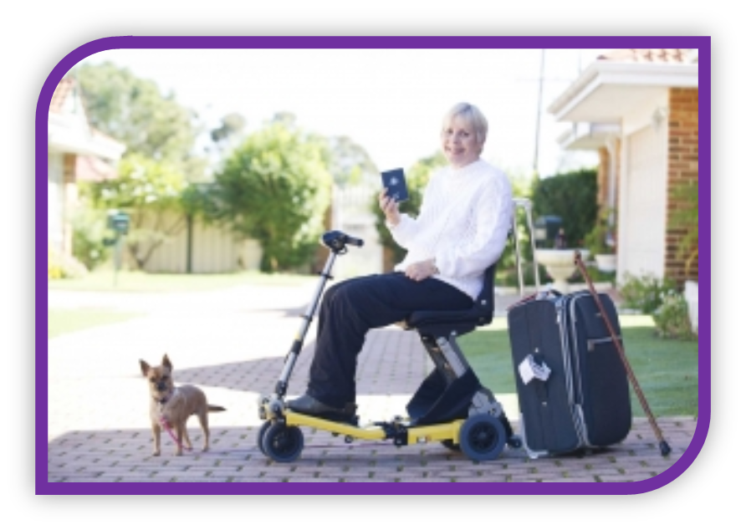

Maintenance and upgrades
We do not fund maintenance or upgrades for home modifications or for homes where it is not directly related to the participant’s disability.

Modification area
We can only fund maintenance confined to the immediate room or area being modified.
Builders are responsible for limiting disturbance to existing walls, floor, ceilings, and roofs as much as possible during the home modifications. Any disturbed areas or components of the participant’s dwelling need to be made good (for example repaired, cleaned or painted) to match existing finishes.
Painting of walls, ceiling and doors or architraves must be confined to the room or area being modified. It is important that the builder ‘makes good’ the areas of the home impacted by modifications.
During the initial assessment and quote, the builder should carefully consider the areas of the dwelling which will be reasonably disturbed because of the works being carried out.

Structural repairs
Any necessary structural repairs need to be confined to, and directly related to, the immediate room or area being modified, such as door widening, recessed sub-floor for a step-less shower base, relocation, or removal of walls.
For example, unless impacted by the home modifications scope of works, we will not fund structural repair of the dwelling subfloor, walls, or roof due to deterioration caused by termite attack, moisture, rot, foundation subsidence or the like.

Electrical
Any electrical works we fund must be confined to, and directly related to, the immediate room or area being modified, such as new or relocated lights, light switches and/or General Power Outlets.
As a result of the home modifications, new wiring may need to be extended back to the main switch board and a Residual Current Device (RCD) provided, to comply with the electrical rules.
We would generally not fund a complete upgrade of a dwelling’s electrical supply, wiring and/or main switch board.

Asbestos and/or hazardous material removal
All associated and reasonable costs to detect, and if necessary, remove asbestos or hazardous materials from the immediate work area impacted in the home modifications would meet the NDIS funding criteria.
The extent of asbestos removal we would fund would generally be confined to those components or areas disturbed by the approved home modifications.
The homeowner is responsible for the removal of any additional areas of asbestos or hazardous materials in the dwelling, which are not impacted by the home modifications scope of works.

Non-compliance of the dwelling and/or property
We would generally not fund rectification of any existing building non-compliance associated with the participant’s dwelling, such as from a previous extension or re-stumping of the dwelling where building permission was not obtained.

Building permissions or permits
Building permissions may be needed due to the cost of the home modifications work, and/or the structural nature of the scope of works.
We will fund all reasonable costs associated with getting building permits, approvals, permissions and certifications for home modifications, in line with all relevant federal, state and territory, and local municipality legislative requirements.

Appendix 1

Minimum standard quote information for builders
A home modifications quote from a builder or contractor needs to include:
- name, registered address, telephone, and email contact details
- ABN
- registered practitioner’s number etc.
- details of insurances
- contract (if applicable)
- signing / acceptance page (if no contract)
- the scope of works
- any relevant documentation, drawings, specifications
- pricing breakdown
  - price
  - GST
  - any provisional sums
  - prime cost items
- exclusions, clarification, qualifications including a list of other supplied items, for example building permits.

Appendix 2
NDIS Act 2013, Section 34 – Extract: Reasonable & Necessary Supports
1) For the purposes of specifying, in a statement of participant supports, the general supports that will be provided, and the reasonable and necessary supports that will be funded, the CEO must be satisfied of all the following in relation to the funding or provision of each such support:
a) the support will assist the participant to pursue the goals, objectives and aspirations included in the participant’s statement of goals and aspirations;
b) the support will assist the participant to undertake activities, to facilitate the participant’s social and economic participation;
c) the support represents value for money in that the costs of the support are reasonable, relative to both the benefits achieved and the cost of alternative support;
d) the support will be, or is likely to be, effective and beneficial for the participant, having regard to current good practice;
e) the funding or provision of the support takes account of what it is reasonable to expect families, carers, informal networks and the community to provide;
f) the support is most appropriately funded or provided through the National Disability Insurance Scheme, and is not more appropriately funded or provided through other general systems of service delivery or support services offered by a person, agency or body, or systems of service delivery or support services offered:
(i) as part of a universal service obligation; or
(ii) in accordance with reasonable adjustments required under a law dealing with discrimination on the basis of disability.
2) The National Disability Insurance Scheme rules may prescribe methods or criteria to be applied, or matters to which the CEO is to have regard, in deciding whether or not he or she is satisfied as mentioned in any of paragraphs (1) (a) to (f).

Appendix 3
Further information
NDIS home modifications information is available on the NDIS website (www.ndis.gov.au)
- Our Guideline – Home modifications
- Home modifications explained
- Providing home modifications
- Assistive technology, home modifications and consumables code guide
Contacting the NDIS
Providers can contact the NDIS for home modification issues via:
- 1800 800 110 (toll free)
- their local NDIS office – see the Provider portal on NDIS website (www.ndis.gov.au)
Feedback
If you have any feedback about this guidance, please email enquiries@ndis.gov.au and clearly reference that you are providing feedback for Home Modifications Guidance for Builders and Designers.

